Danielle Sousa

CS-499 Computer Science Capstone

Instructor: Professor Kraya

3/21/2025

**Narrative One: Sofware Design and Engineering**

1. **Briefly describe the artifact. What is it? When was it created?**

The artifact is an Events tracking app that was created in the CS-360 course Mobile Architecture and Programming in Android Studio using Java code. The goal of the application is to track events that are logged by the user to a calendar on the user’s mobile phone. The user can Add, delete or update existing events in SQL Lite database. When the event is approaching its start time an SMS notification will be sent to the user to notify them of the upcoming event as a reminder. This artifact was created in April of 2024.

1. **Justify the inclusion of the artifact in your ePortfolio. Why did you select this item? What specific components of the artifact showcase your skills and abilities in software development? How was the artifact improved?**

I chose this artifact for several reasons. One, when I developed this app, I had not completed it functionality and I thought this would be a great way to showcase my abilities in what I have learned throughout my time at SNHU. Secondly, since it had been some time since this application was created it would allow me to reacquaint myself with the material and IDE and get more hands-on time with this artifact. The specific components that showcase my skill and abilities in the Software Design and Engineering portion are within the user interface portion of the application under activity_main_login and activity_register xml files as well as the MainActivityLogin and RegisterActivity file code which is the functionality of the user interfaces for login in a user and signing up a user for a new account. . The artifact was improved by adding more visuals to the main login page and sign-up page, such as an icon representing what the page is about. I also implemented a password recovery link and a Remember me check box on the login screen. For the password recovery link, I had to create a new class for forgotpassword to give functionality to the forgot password link on the login screen. I also added code to the MainActivityLogin file for the Remember me check box to add functionality to populate the username and password fields if the box is checked by the user. I decided to keep the footer and header however, I did minor changes to the color of the buttons.

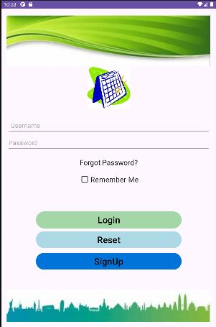

1. **Did you meet the course outcomes you planned to meet with this enhancement in Module One? Do you have any updates to your outcome-coverage plans?**

Yes, I believe that I did meet the course outcome of demonstrating the ability to use well-founded and innovative techniques, skills, and tools in computing practices to implement computer solutions that deliver value and accomplish industry-specific goals. I did make a change that I had not considered before and that was to add the remember me check box. I believe this would be more of a convenience for the user. I also changed the register activity screen which I had only considered changing the login screen. I added a logo for that screen as well to give users a visual representation of what screen they are looking at.

1. **Reflect on the process of enhancing and modifying the artifact. What did you learn as you were creating it and improving it? What challenges did you face?**

What I learned while completing my first enhancement was that I had to keep the mindset of error handling. I found this a little challenging because I am not well-versed in this area, and considering all possibilities can take significant time and is easy to overlook.